From: https://davidstockmanscontracorner.com/cyclical-old-age-does-not-become-her-the-case-of-the-auto-debtberg/

Cyclical Old Age Does Not Become Her: The Case Of The Auto Debtberg
By David Stockman. Posted On Tuesday, October 1st, 2019
Here is the broadest picture of the American consumer and it sure looks like there's more dropping than shopping going on. So if personal consumption spending (PCE) is the great 70% engine that's supposed to keep the GDP growing, then the August PCE report might beg to differ: Real spending grew a mere 2.27% over prior year.
The fact is, four of the five core GDP sectors have already thrown in the towel. Housing and business CapEx are flatlining, net exports are heading south (thank you, POTUS) and the government sector already is bulging with red ink.
So if the vaunted American consumer is now slouching towards stall speed---a trend which has been underway since real consumption spending growth peaked at 4.5% back in February 2015---from whence cometh the stick save for an aging business cycle that is on the verge of rolling over?
The answer, of course, is that there will be none. Not from the Fed and not from anyone else because the Fed's massive 10-year long "stimulus" in the form of NIRP and QE did not fix the economy that collapsed in 2008; it just injected it with palliatives that actually aggravated the on-going metastasis below the surface.
What the Wall Street permabulls and Keynesian stimulus preachers don't get is that under the current central banking regime, the advancing age of the business cycle does not become her. In mechanical terms, months 120-130 of the cycle (where we are now at the never before recorded mid-point) are far more precarious than months 20-30 because Keynesian policy is a form of dissolute economic living.
Accordingly, the longer the stimulus is applied, the more unsustainable debt, speculation and malinvestment builds up throughout the warp and woof of the financial system and underlying economy. Like alcoholism in humans, Keynesian stimulus is a progressive disease that leaves the body economic ever more vulnerable to external shocks, otherwise known as black swans.
The heart of the matter is deep and sustained interest rate repression. It means that prior excesses are never ameliorated or purged. They just become the rotten foundation on which new layers of debt, speculative excess and economic "mistakes" are layered upon.
So when all five sectors of the GDP (excluding second order change in highly volatile business inventories) are limping and listing toward the flat-line in month #124 of a business expansion, you can be sure that the economy is literally riddled with disease.
The investment and spending mistakes fostered by 10-years of artificially cheap debt and the desperate scramble for yield among investment managers eventually overwhelm capitalism's inherent forward momentum.
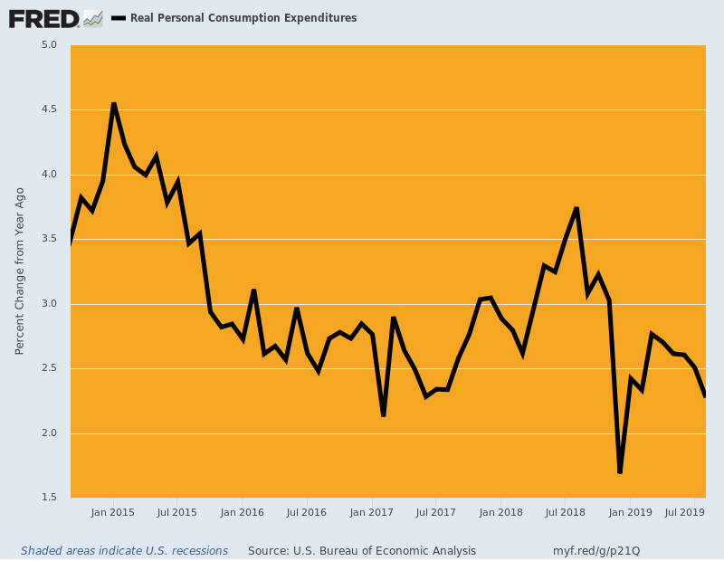
A Wall Street Journal story today nicely illustrates this progressive disease syndrome and is fittingly entitled, "The Seven-Year Auto Loan: America's Middle Class Can't Afford Their Cars".
The jist of the article is that since 2009 the average transaction price of new autos has risen from $30,000 to $40,000 or by 33%. That compares to a just a 25% gain in average hourly earnings---a shortfall which would have materially squeezed auto affordability in an honest finance market.
But what happened instead is that auto loan maturities were substantially lengthened so that the lagging wages did not cut into loan-financed demand. That is, buyers purchased ever more expensive vehicles at a constant share of wages simply by kicking the debt can further down the road:
Walk into an auto dealership these days and you might walk out with a seven-year car loan.
That means monthly payments that last well past when the brake pads give out and potentially beyond when the car gets traded in for a new one. About a third of auto loans for new vehicles taken in the first half of 2019 had terms of longer than six years, according to credit-reporting firm Experian PLC. A decade ago, that number was less than 10%.
For many Americans, the availability of loans with longer terms has created an illusion of affordability. It has helped fuel car purchases that would have been out of reach with three-, five- or even six-year loans.
At the same time, the size of the average auto loan has grown by about one-third over the last decade from $24,000 to about $32,000 for new vehicles. So from a debt burden viewpoint, it's a case of "bigger for longer".
It's also a second cousin to Charles Ponzi. What is happening is that the share of auto trade-ins with negative equity has soared from 17% in 2009 to 27% by 2014 and then to nearly 34% at present.
Needless to say, owing $5,000 or $7,000 more than a 7-year old vehicle is worth would ordinarily be a huge barrier to getting a brand new ride. The borrower would either need to default on the old loan, thereby causing their credit score to tumble, or reach into savings to pay-off the old loan and potentially have nothing left for a new car down payment.
But to paraphrase the late night TV pitchman: Negative equity? No problem!
That's right. What the industry debt machine is doing is simply rolling negative equity into the new vehicle loan. That means, in turn, the new loan advance rate is often 115% or even 135% of the transaction price of the new car being purchased.
Do that a couple of purchase cycles, of course, and even Charles Ponzi would be impressed.
Indeed, the WSJ story incudes an anecdote of how a 22-year old minimum wage worker got himself a new Honda Accord in just that way. We are kind of partial to this story because it happened in the namesake of our long ago home town in Flyover America and involves a transaction so devoid of common sense that back in the day it would have been considered sheer lunacy:
Deven Jones walked into the Rolling Hills Honda dealership in St. Joseph, Mo., about three years ago after a salesman emailed him and said he might be able to buy a new car for less than $400 a month.
Mr. Jones, now 22 years old, walked out with a gray Accord sedan with heated leather seats. He also took home an 84-month car loan that cost him and his then-girlfriend more than $500 a month. When they split last year and the monthly payment fell solely to him, it suddenly took up more than a quarter of his take-home pay.
He paid $27,000 for the car, less than the sticker price, but took out a $36,000 loan with an interest rate of 1.9% to cover the purchase price and unpaid debt on two vehicles he bought as a teenager. It was particularly burdensome when combined with his other debt, including credit cards, he said.
A 133% loan-to-value ratio for 1.9% interest? Exactly what alien economic planet have we landed upon!
As the WSJ story further noted, we have now reached the point where just 18% of US households have enough liquid assets to cover the cost of a new car.
In fact, if the median income U.S. household ($63,000) were to employ even a moderately conservative financing and take out a 4-year loan with a 20% down payment while keeping the interest cost under 10% of gross income---a standard ratio---it could afford a new car worth just $18,390.
So you better make that a mountain bike with a battery-pack, instead.
Nor is that the extent of the impairment. Since 80% of households must now plunge deep into debt with loans so large and burdensome that they actually destroy the borrowers equity, the auto sales business has been transformed as well.
Dealers now make more money from financing cars than they do from selling them!
So far this year, dealerships made an average of $982 per new vehicle on finance and insurance versus $381 on the actual sale, according to J.D. Power, a data and analytics company. A decade earlier, financing brought in $516 per car and the sale made dealers $837.
Needless to say, where all this cheap debt comes from is not hard to find. The Fed's ultra-low rates functioned as a rolling bailout for the entire auto industry. Fund managers desperate for yield lined up around the block and back for securitized auto loans.
Last year, investors bought a record $107 billion of bonds backed by cars, causing total outstandings to rise to $264 billion compared to just $100 billion in 2009.
Moreover, the securitized portion of the Auto Debtberg is only the tip of the thing. Overall, auto debt outstanding now totals $1.3 trillion compared to $740 billion in the immediate aftermath of the financial crisis.
And not surprisingly, in some large dealerships which push loans to anyone who walks into the showroom and can fog a rearview mirror, some 40% of employers are in the loan collection business.
A further anecdote in the WSJ story reminds where the auto Debtberg ultimately leads:
In mid-April, a representative who handles the most-difficult cases called a past-due borrower to iron out payment on a 2018 Toyota RAV4. The borrower had struggled to keep up with a payment of more than $800. The car already had been repossessed from the borrower once.
The Westlake representative switched between English and Spanish. He offered an extension on the March payment, meaning it wouldn’t be due until the end of the loan in 2024. But he collected nearly $600 on a partial payment for April over the phone. Borrowers are less likely to resume payments if they stop altogether.
After hanging up, the representative rang a bell at his desk. “35K,” he called out, referring to the balance of the loan that was no longer considered seriously delinquent. “It took a while but I got ’em.”
Actually, where it really leads on an aggregate basis is to a debt encumbered dead-end.
Thus, total US light vehicle sales plateaued at about 17 million units annualized in late 2006-early 2007. They plunged as low as a 10 million rate during the Great Recession and market disorder owing to the bankruptcy of GM and Chrysler, but then fought their way back to the 17 million level by May 2014. They have pretty much flat-lined around that level ever since.
But not so with the above referenced Auto Debtberg. By May 2014 auto debt outstanding (brown line) was already 20% higher than the January 2007 level, and then it has just kept climbing, reaching 150% of its 2007 level in Q2 2019.
What that means is that for the last five years auto sales have flat-lined (purple line), even as auto debt has continued to soar.
In short, during the current so-called recovery cycle it took a 50% increase in auto debt outstanding simply to get annual sales back to the 17 million marker set 12 years ago in January 2007.
That's the stimulus disease at work. When the next recession inexorably arrives, far more auto-borrowers will be under water and will be unable to pay when their jobs or incomes dry up. Yet the amount of auto paper in harm's way will be 50% larger.
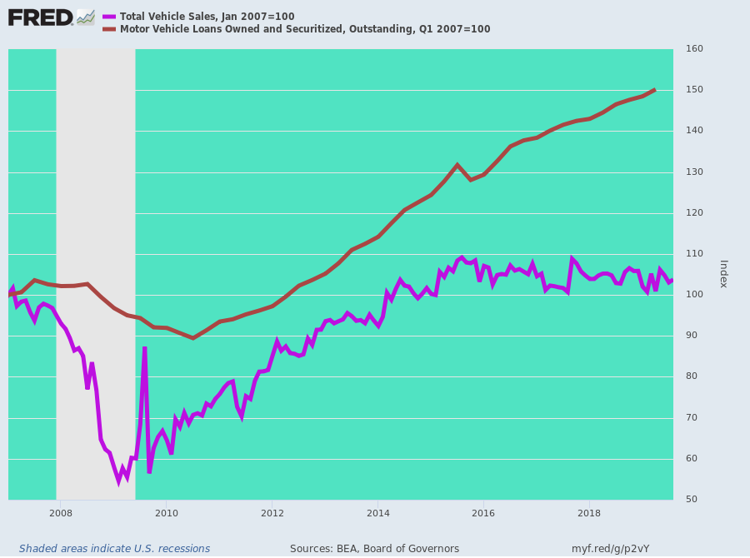
So we return to the larger proposition. Our Keynesian stimulus preachers never, ever look under the balance-sheet hood. They are totally flow-obsessed.
So are cars still selling at the respectable 17 million rate represented by the purple line after 2014 in the chart above?
Why, yes they are.
Is the Auto Debtberg heading skyward?
Apparently, you are not supposed to ask.

